Pet Adoption App

Team Members:

Daniel Pivonka

Brianne Bindas

Scott Melo

App Features:

Our app will request data from the Petfinder API <https://www.petfinder.com/developers/api-key> .

This data will be full of all kinds of animals and their info, that are up for adoption.

We will take this data and fill a database with the info from Petfinder.

The user will be able to fill out a form of what kind of animal, breed, color, age, etc…

This information will then be used to find all valid matches in the database

All the matches will be return to the user allowing them to search thru them

If an animal is clicked on it will open a page with more info about it.

It will also contain a button allowing them to add it to a list of favorites.

As well as a button to share the info thru text or email.

Duties:

Daniel: Api/network

Brianne: UI

Scott: database

Main page

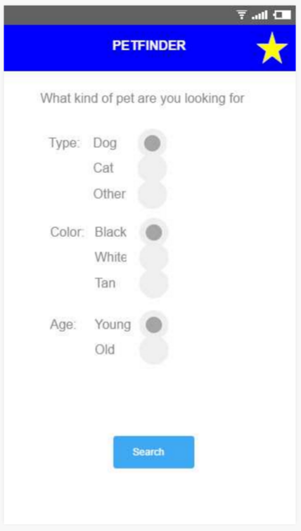

Pet List based on what was selected on homepage

Can also be used for favorites page

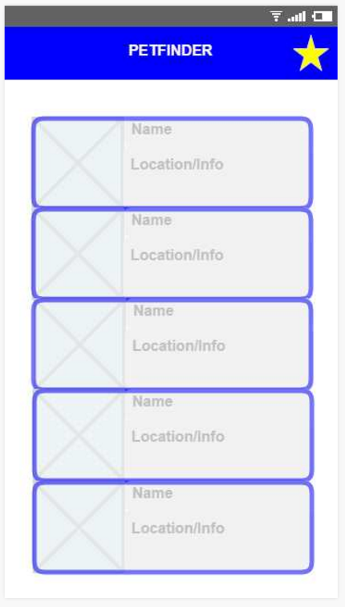

Page for single pet

